**Module 4 : Data Security**

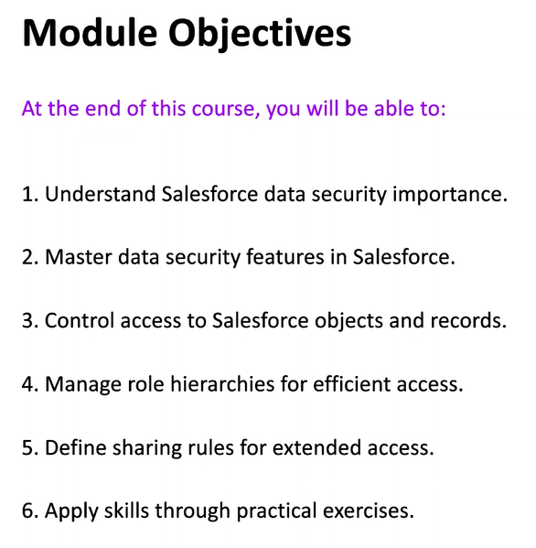

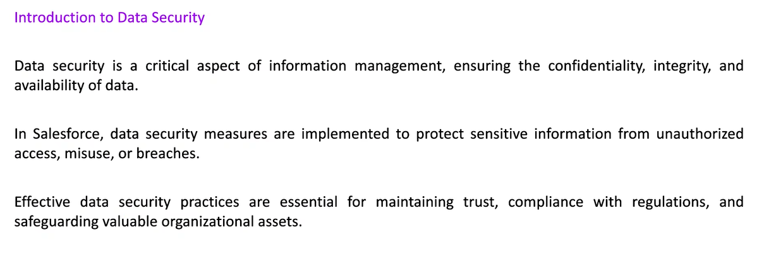



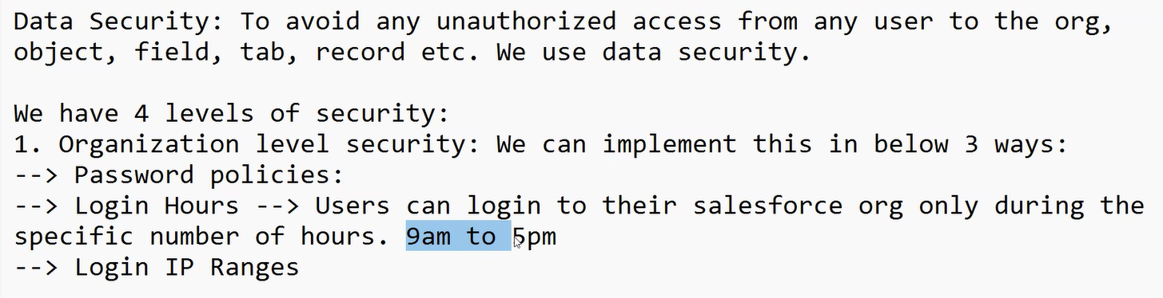

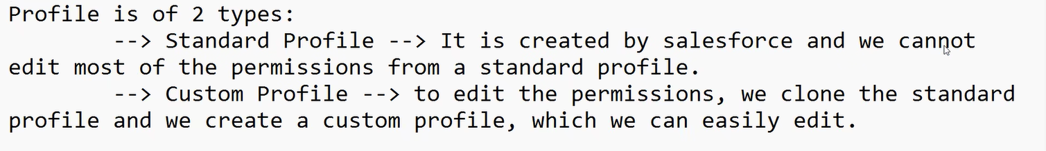

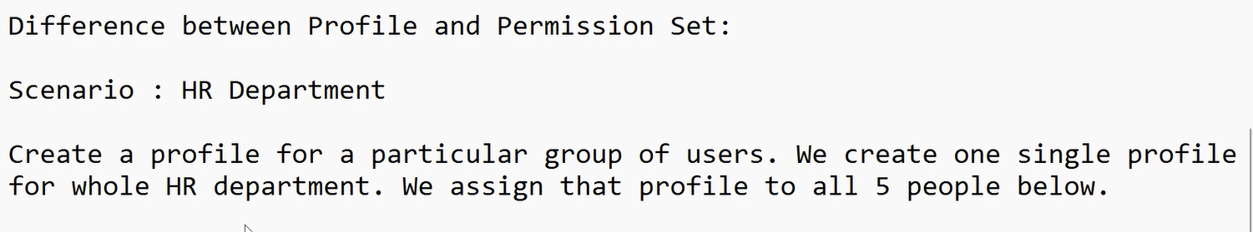

Only want to give read permission to analyst, to give different permission we will create diff profile for permission, but its not good to create new profile to give single permission.

We say give minimum level of access to permission in profile and assign it to all of them,

To give addition permission, we can create **permission** **set**.

Profile = min. level of permission

Permission set = additional permission



